 | 7.0.12 Editors - 3D Viewport - Grease Pencil object - Edit Mode - Point+Stroke context menu
Table of content
Edit Mode - Point+Stroke Context Menu 4
Subdivide 4
Last Operator Subdivide 4
Number of Cuts 4
Smooth 4
Repeat 4
Selected Points 4
Position 4
Thickness 4
Strength 5
UV 5
Simplify sub menu 5
Fixed 5
Last Operator Simplify Fixed Stroke 5
Steps 5
Adaptive 5
Last Operator Simplify Stroke 5
Factor 5
Sample 5
Last Operator Sample Stroke 5
Factor 5
Trim 5
Extrude 6
Smooth 6
Last Operator Smooth Stroke 6
Repeat 6
Factor 6
Selected points 6
Position 6
Thickness 6
Strength 6
UV's 6
Bend 6
Shear 6
Last Operator Shear 7
Offset 7
Shear Axis 7
Axis 7
Axis Ortho 7
Orientation 7
Proportional editing 7
Proportional Falloff 7
Proportional Size 7
Connected 7
Projected(2D) 7
To Sphere 7
Usage 8
Last Operator To Sphere Panel 8
Factor 8
Proportional editing 8
Proportional Falloff 8
Proportional Size 8
Connected 8
Projected(2D) 8
Shrink/Fatten 8
Last Operator Shrink/Fatten 9
Offset 9
Offset Even 9
Proportional editing 9
Proportional Falloff 9
Proportional Size 9
Connected 9
Projected(2D) 9
Move to Layer 9
New Layer 9
Last Operator Move Strokes to Layer 10
Grease Pencil Layer 10
Assign Material 10
Last Operator Change Stroke Color 10
Material 10
Set as active material 10
Arrange 10
Bring Forward 11
Send Backward 11
Bring to Front 11
Send to Back 11
Last Operator Arrange Stroke 11
Direction 11
Mirror submenu 11
Interactive Mirror 11
X Global, Y Global etc. 11
Last Operator Mirror 11
Orientation 11
Constraint Axis 11
Proportional editing 12
Proportional Falloff 12
Proportional Size 12
Connected 12
Projected(2D) 12
Snap submenu 12
Last Operator Snap 12
Offset 12
Duplicate 12
Last Operator Duplicate 12
Mode 12
Move X, Y, Z 12
Orientation 13
Constraint Axis 13
Proportional editing 13
Proportional Falloff 13
Proportional Size 13
Connected 13
Projected(2D) 13
Copy 13
Paste 13
Paste by Layer 13
Last operator Paste Strokes 13
Type 13
Merge 14
Last Operator Merge Strokes 14
Mode 14
Draw on back 14
Additive drawing 14
Cyclic 14
Dissolve Points 14
Delete Strokes 14
Merge by Distance 14
Last Operator Clean Loose Points 14
Threshold 14
Unselected 14
Join 14
Last Operator Join Strokes 15
Type 15
Leave Gaps 15
Split 15
Separate 15
Last Operator Separate Strokes 15
Mode 15
Active Layer 15
Selected Strokes 15
Selected Points 15
Delete Points 15
Last Operator Delete 15
Type 15
Dissolve 15
Dissolve 16
Dissolve Between 16
Dissolve Unselect 16
Last Operator Dissolve 16
Type 16
Re project Strokes 16
Last Operator Re project Strokes 16
Projection Type 16
Show/Hide 16
Show All Layers 16
Adjust Last Operator Show all Layers 16
Select 16
Hide active Layer 16
Hide inactive Layer 16
Adjust Last Operator Hide Layer(s) 17
Unselected 17

Edit Mode - Point+Stroke Context Menu

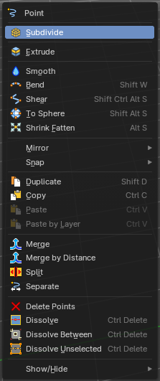
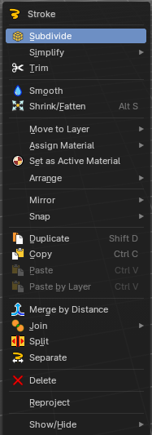
Call this menu with right click in the 3D viewport. The different menus appears dependant of the select mode.
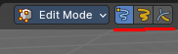

Subdivide
Subdivides the selected grease pencil geometry.

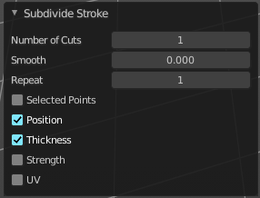
Last Operator Subdivide

Number of Cuts
Number of subdivision cuts.

Smooth
Smoothen the stroke, not just the new added vertices

Repeat
The number of times to repeat the procedure.

Selected Points
Limits the effect to only the selected points within the stroke.

Position
The operator affects the points location.

Thickness
The operator affect the points thickness.

Strength
The operator affect the points strength (alpha).

UV
The operator affect the UV rotation on the points.

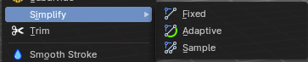
Simplify sub menu
Stroke mode. Simplify the stroke.

Fixed
Deletes every second point in the stroke, except the start and end points.

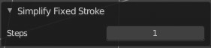
Last Operator Simplify Fixed Stroke

Steps
How much levels of simplifying.

Adaptive
This method uses an algorithm called RDP algorithm (Ramer-Douglas-Peucker algorithm) for points deletion. The algorithm tries to keep the shape with the remaining points.

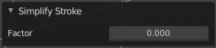
Last Operator Simplify Stroke

Factor
How strong the simplification should be performed.

Sample
Samples points along the shape of the stroke, and increases the length of the edges.

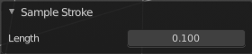
Last Operator Sample Stroke

Factor
How long the edges between the points should be.

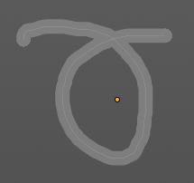
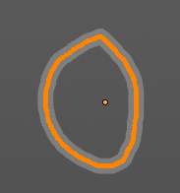
Trim
Trims down selected stroke geometry to first loop or intersection.

Extrude
Extrudes out the selected points. The new points stay connected with the original points of the stroke.

Smooth
Smoothens out the selected geometry.

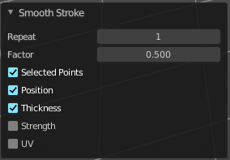
Last Operator Smooth Stroke

Repeat
How often to repeat the procedure.

Factor
The amount of the smoothness to apply.

Selected points
When enabled, limits the effect to only the selected points within the stroke.

Position
When enabled, the operator affect the points location.

Thickness
When enabled, the operator affect the points thickness.

Strength
When enabled, the operator affect the points strength (alpha).

UV's
When enabled, the operator affect the UV rotation on the points.

Bend
Bends the selection.

Shear
Shear shears the selection.


Last Operator Shear

Offset
Adjust an offset.

Shear Axis
The shear tool works along a imaginary 2d plane. The shear axis controls if the items are sheared along the x or the y axes of this plane. This is the plane along which the transformation happens. You can shear along the x or the y axis of this plane.
To make things even more complicated, the orientation of this imaginary plane is defined by the Axis and AxisOrtho items below.

Axis
Defines one axis of the imaginary shear axis plane.


Axis Ortho
Defines the other axis of the imaginary shear axis plane.

Orientation
Choose the orientation for the shear action.

Proportional editing

Enables proportional editing. Activating proportional editing reveals further settings.

Proportional Falloff
Adjust the falloff methods.

Proportional Size
See and adjust the falloff radius.

Connected
The proportional falloff gets calculated for connected parts only.

Projected(2D)
The proportional falloff gets calculated in the screen space. Depth doesn't play a role. When it's in the radius, then it gets calculated.

To Sphere
Shapes a selection of objects into the shape of a sphere. The calculation happens with the object origins.

Usage

Select the vertices, activate the tool, then drag the mouse in the 3D viewport. In the header you will read the current factor then. Which tells you how close you are towards the sphere shape.



Last Operator To Sphere Panel

Factor
The factor to transform the selection into a shape form.

Proportional editing
Enables proportional editing. Activating proportional editing reveals further settings.

Proportional Falloff
Adjust the falloff methods.

Proportional Size
See and adjust the falloff radius.

Connected
The proportional falloff gets calculated for connected parts only.

Projected(2D)
The proportional falloff gets calculated in the screen space. Depth doesn't play a role. When it's in the radius, then it gets calculated.

Shrink/Fatten
Shrink/Fatten scales the selected geometry along its normals. Transform orientation and Pivot point gets ignored.
A positive value pushes the vertices outwards. A negative value pushes the vertices inwards.


Last Operator Shrink/Fatten
The Last Operator Shrink/Fatten panel gives you tools to adjust the Shrink/Fatten operation. Here you have numeric input for the strength and a few more options.

Offset
Offset is the strength of the offset for Shrink/Fatten.

Offset Even
Offset Even scales the selection to give more thickness in even areas.

Proportional editing
Enables proportional editing. Activating proportional editing reveals further settings.

Proportional Falloff
Adjust the falloff methods.

Proportional Size
See and adjust the falloff radius.

Connected
The proportional falloff gets calculated for connected parts only.

Projected(2D)
The proportional falloff gets calculated in the screen space. Depth doesn't play a role. When it's in the radius, then it gets calculated.

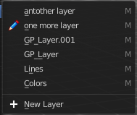
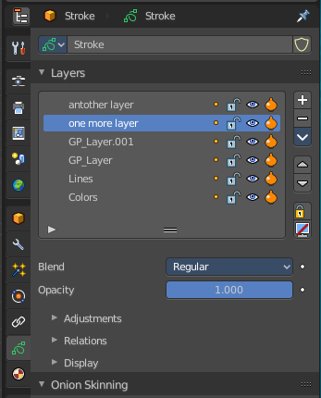
Move to Layer
Move the current selected stroke to another grease pencil layer. It lists the current layers.

New Layer
New Layer button adds a new grease pencil layer.

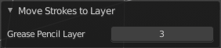
Last Operator Move Strokes to Layer

Grease Pencil Layer
Internal the layers are enumerated. So here you move by number.
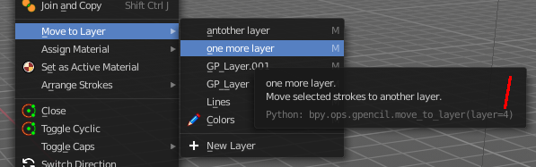
The number of a layer can be found out in the tool tip, in the Python part of it.

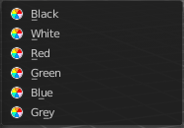
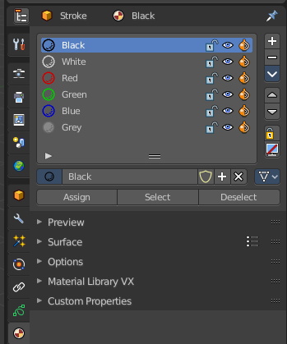
Assign Material
Assign a new material to the current selected stroke geometry.
The materials can be found and edited in the Properties editor. Here you can also create new materials.

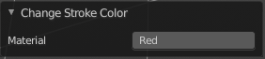
Last Operator Change Stroke Color

Material
The materials are defined by its name. So when you want to use another material, then change the name here.

Set as active material
Sets the current selected material as the active material.

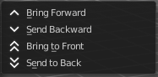
Arrange
Changes the drawing order of the strokes in the 2D layer.

Bring Forward
Moves the selected points/strokes upper the next one in the drawing order.

Send Backward
Moves the selected points/strokes below the previous one in the drawing order.

Bring to Front
Moves to the top the selected points/strokes.

Send to Back
Moves to the bottom the selected points/strokes.

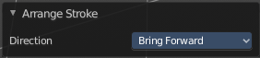
Last Operator Arrange Stroke

Direction
Choose the method again.

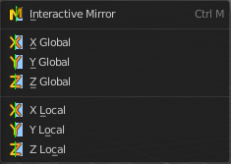
Mirror submenu
Mirror mirrors the selected geometry along the defined axis.

Interactive Mirror
Mirror by hotkeys. You activate the tool, type in x for x global for example, or x x for x local. And the selection gets mirrored.

X Global, Y Global etc.
Mirrors the selection around the chosen axis.

Last Operator Mirror

The Last Operator Mirror panel gives you tools to adjust the mirror action.

Orientation
Orientation is a drop-down box. Choose the type of orientation for the mirroring action.

Constraint Axis
Constraint Axis gives you again the possibility to define the mirror axis. You can choose more than one axis here.

Proportional editing
Enables proportional editing. Activating proportional editing reveals further settings.

Proportional Falloff
Adjust the falloff methods.

Proportional Size
See and adjust the falloff radius.

Connected
The proportional falloff gets calculated for connected parts only.

Projected(2D)
The proportional falloff gets calculated in the screen space. Depth doesn't play a role. When it's in the radius, then it gets calculated.

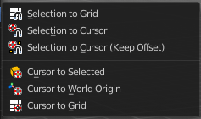
Snap submenu
Choose several methods to snap one element to another. The menu items should be self explaining.

Last Operator Snap

Some snap operations shows a last operation panel, some not.

Offset
If the selection should snap as a whole, or if each individual element of the selection should snap.

Duplicate
Duplicates the current selection.
When you duplicate a selection, then it sticks to the mouse until you left click. And moves around. A right click repositions the duplicated geometry at its original location.

Last Operator Duplicate

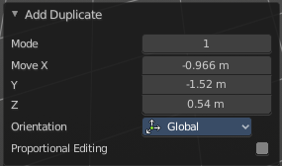
Mode
Not to find out. No tool tip, no entry in the Blender manual. Good Job Blender Developers.

Move X, Y, Z
Adjust the position.

Orientation
Orientation is a drop-down box. Choose the type of orientation for the mirroring action.

Constraint Axis
Constraint Axis gives you again the possibility to define the mirror axis. You can choose more than one axis here.

Proportional editing
Enables proportional editing. Activating proportional editing reveals further settings.

Proportional Falloff
Adjust the falloff methods.

Proportional Size
See and adjust the falloff radius.

Connected
The proportional falloff gets calculated for connected parts only.

Projected(2D)
The proportional falloff gets calculated in the screen space. Depth doesn't play a role. When it's in the radius, then it gets calculated.

Copy
Copies the selection.

Paste
Pastes a copied selection to active layer. You can have more than one layer.

Paste by Layer
Pastes a copied selection to same, original layer. You can have more than one layer.

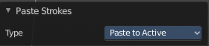
Last operator Paste Strokes

Type
Choose between the paste methods again.

Merge
Allows you to paint a new stroke between the selected vertices. The selected points are not merged though, but a new stroke is created.

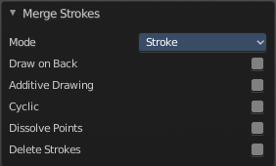
Last Operator Merge Strokes

Mode
Choose between stroke or point mode.
This feature is not documented in the Blender manual, there is no explanation in the tool tip, and it is not to find out what the difference is. Both do the same.

Draw on back
Draw the new stroke below all other strokes.

Additive drawing
Add to previous drawing

Cyclic
Close the new stroke

Dissolve Points
Dissolve the old selected points.

Delete Strokes
Deletes the old selected strokes.

Merge by Distance
Merges vertices that are close to each other.

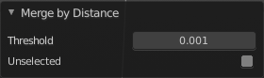
Last Operator Clean Loose Points

Threshold
The distance.

Unselected
Merge also unselected geometry.

Join
Join selected strokes by connecting points.

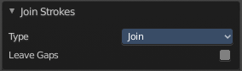
Last Operator Join Strokes

Type
Join or Join and Copy.

Leave Gaps
Don't connect the strokes by geometry.

Split
Splits the selection.

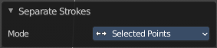
Separate
Separates the selection into a new grease pencil object.

Last Operator Separate Strokes

Mode

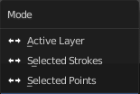
Active Layer
Separate all the strokes at the current active layer.

Selected Strokes
Separate the whole stroke of the current selection.

Selected Points
Separate the selected points with its edges.

Delete Points
Delete selected stroke points.

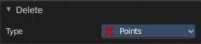
Last Operator Delete

Type
Choose what you want to delete.

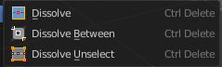
Dissolve
Dissolve is a union operation. Two edges becomes one edge by removing the vertice in between.

Dissolve
Dissolves the selection.

Dissolve Between
Dissolves the vertices between the selected vertices.

Dissolve Unselect
Dissolves the vertices that are not selected.

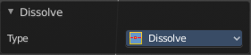
Last Operator Dissolve

Type
Choose how you want to dissolve.

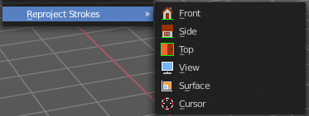
Re project Strokes
Re projects the selected stroke points in the selected view method.

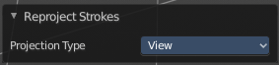
Last Operator Re project Strokes

Projection Type
Choose the method again.

Show/Hide

Show All Layers
Shows all invisible layers again.

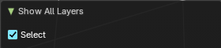
Adjust Last Operator Show all Layers

Select
Select the geometry.

Hide active Layer
Hide the active layer.

Hide inactive Layer
Hide the inactive layers.

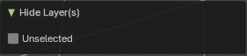
Adjust Last Operator Hide Layer(s)

Unselected
Hide the unselected layers instead of the selected layer.

